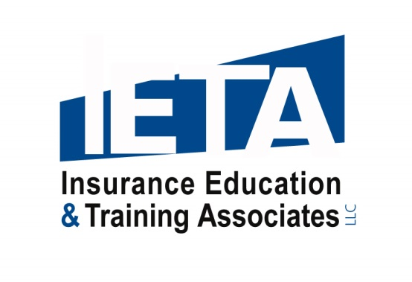

**Robin Federici Biographical Sketch - 2017**

Robin Federici , CPCU, AAI, ARM, AINS, AIS, CPIW has been writing and presenting insurance education programs to the insurance industry for over 35 years.  She formed **Insurance Education & Training Associates (IETA)** of Newport, Rhode Island in 2003, after serving the Independent Insurance Agents of Rhode Island (IIARI) for sixteen years; first as Director of Education and subsequently as Assistant Executive Vice President.

This followed a lengthy career in both underwriting and sales with insurance agencies and companies.  Even during her agency and company days, Robin created education courses to present to her peers as a volunteer instructor for IIARI.

Robin is a technical insurance and agency management expert with the Independent Insurance Agents & Brokers of America’s *Virtual University*.

This role, coupled with her extensive background in both the agency and company ranks, and her love of teaching, adds a unique dimension and immediate and practical value to the programs she presents to insurance professionals countrywide.

Robin is also the author of Swiss-Re’s current E&O program – “E*&O Management – Meeting the Challenge of Change*”.

####  
February 2, 2018  
www.ieta.biz